

|  |  |
| --- | --- |
|  | Connect to Virtual Training Network |

|  |
| --- |
| **Classification:** ~~SECRET/HIGHLY CONFIDENTIAL~~/**CONFIDENTIAL**/ ~~UNRESTRICTED~~ (Tick the Relevant Classification)  Do not forward or copy data in part or full without explicit permission of LKM Leads  Data access is limited to------------------------(URL of list)  Use Strong authentication / EFS Encryption / Lock in a Drawer  Log access in a register  Retention period is -- as per Policy 123  Check the relevant Handling guidelines above. |
|  |

**Revision History**

|  |  |  |  |  |  |
| --- | --- | --- | --- | --- | --- |
| Version | Date | Author | Reviewed by | Approved By | Comments |
| 1.0 | 21st Aug 2020 | Babu.raj.pr | Reddy Mutra, Narendra | Prabhakara.prabhu | Initial baselined document. |
| 1.1 | 27th Sept 2022 | eniyavan.ranganathan | Reddy Mutra, Narendra | Prabhakara.prabhu | Updated document. |
|  |  |  |  |  |  |
|  |  |  |  |  |  |

1. **Step to start your training instance**
2. Click on the below link to View the training setup enabled for you.

<https://atcitrainingtracker.accenture.com/OnlineTrainingtracker/ViewMytrainingSetups.aspx>

1. Please provide Accenture email ID and password to login if asked to authenticate.

**Result:** You can see the screen like below with your training details.

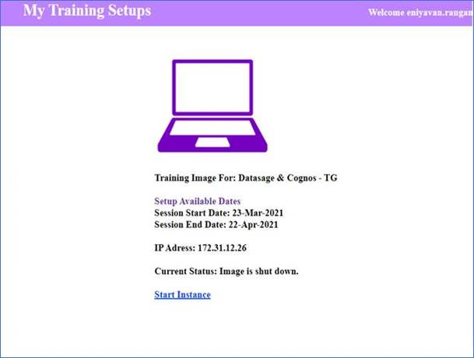

1. Click on the “Start Instance” link and please wait for the instance to start. The status will be shown as “Image is starting… please wait” as shown in the below screenshot. It may take 30 seconds to start. Refresh the screen in case the status does not change for long.

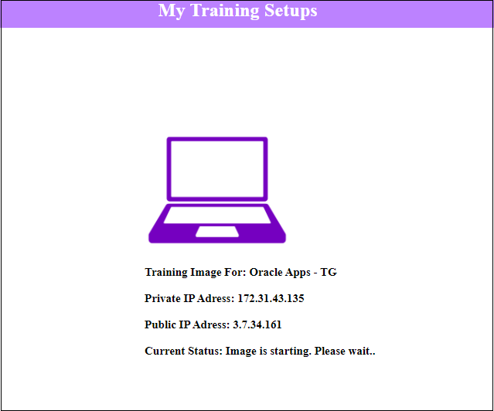

d. If the Virtual Machine is up and running, you can see the current status as “**Image is ready for use**”. Now the Virtual image is ready to login and use.

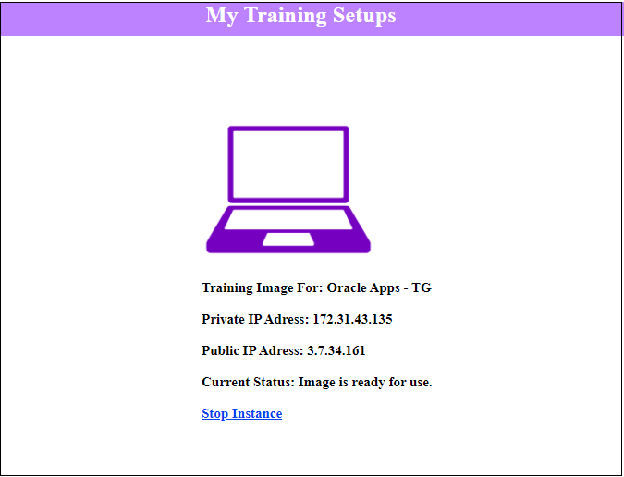

1. **Steps to connect to LKM VPN**

Complete the Pre-requisite configuration steps outlined the below attachment document (*Applicable only for the participants using their personal system)*

1. Click on start button and Search for “Pulse Secure” App and click on “Open” to open Pulse Secure Application.

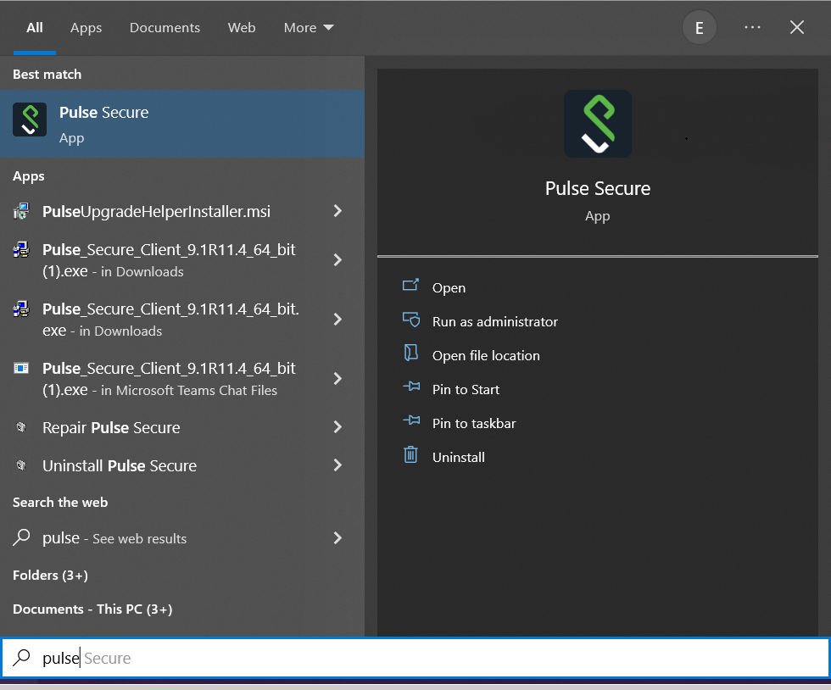

**Result:** Pulse secure app will be opened as shown in the below snapshot.

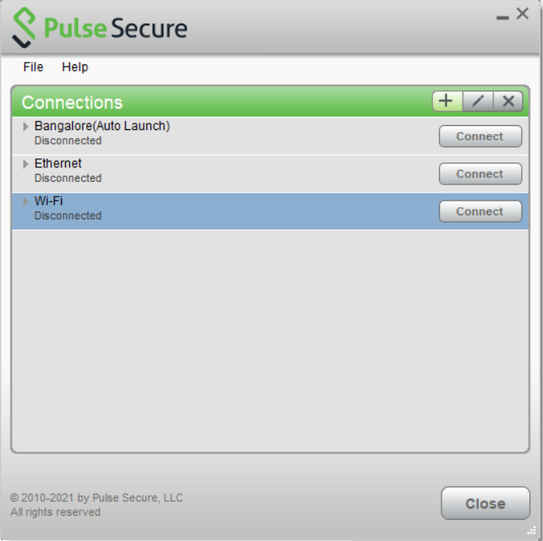

1. Click on “Plus Icon” to add the connection.

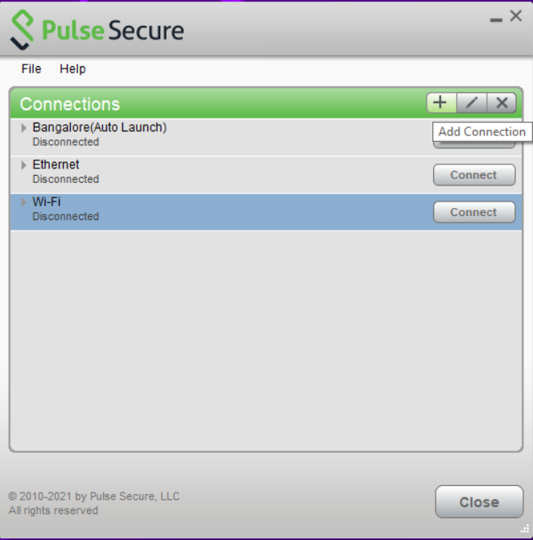

1. In “**Name”** field provide any name Ex: - “LKM MDC6” and in “**Server URL**” field copy paste the VPN link “<https://mdc6-gdnras.accenture.com/LKM>“ and click on Connect button.

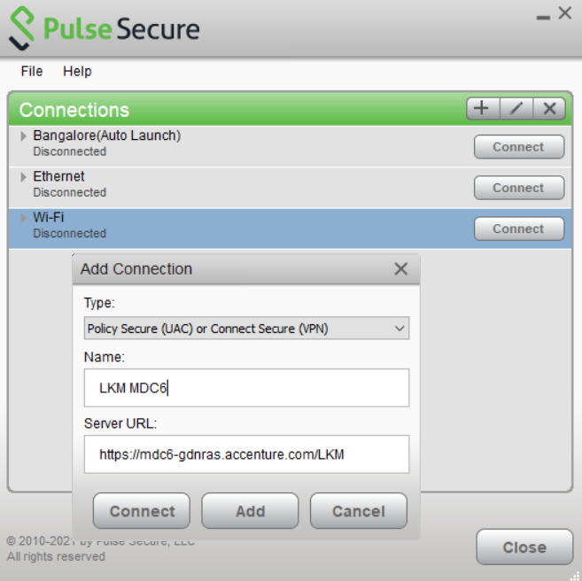

1. Pulse Secure tool will try connecting to VPN. This includes checking for machine compliance. This process will take some time and so please wait for a couple of minutes to complete.

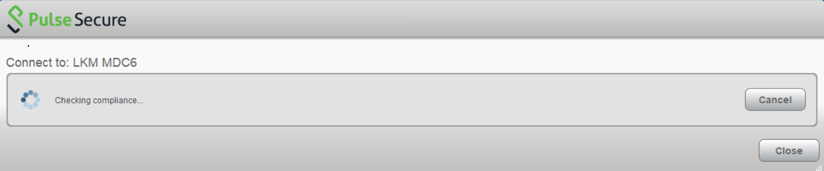

1. Once your machine found compliant, PulseSecure will establish a connectivity to VPN.

Refer to the below Snapshot for connectivity confirmation with a green Tick mark.

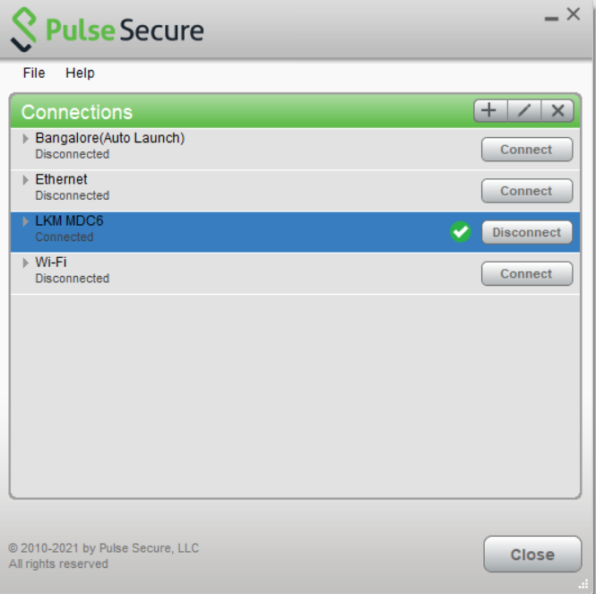

1. **Steps to access the Remote Training Environment:**

After successful connection to the VPN, please follow the below steps to access the Virtual Training machine.

1. On Windows PC, In the search button on the taskbar, type **Remote Desktop Connection**, and then select Remote Desktop Connection.

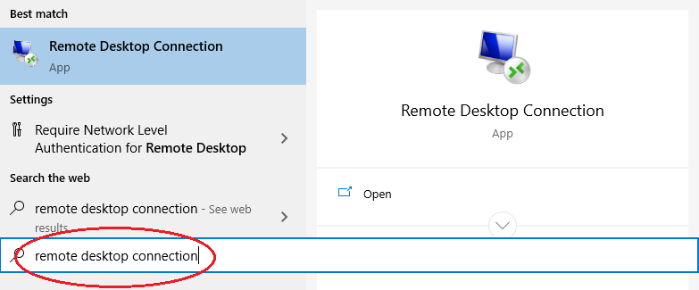

1. In the ‘computer’ field, type the **private IP shared** mentioned on the email, and then click Connect.

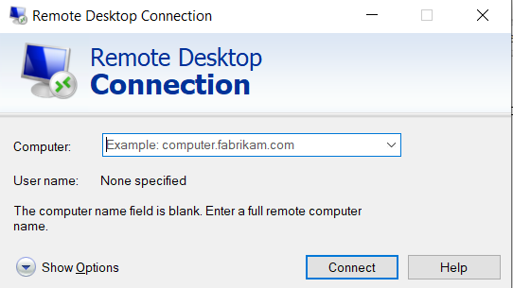

1. Click on more choices & use a different account

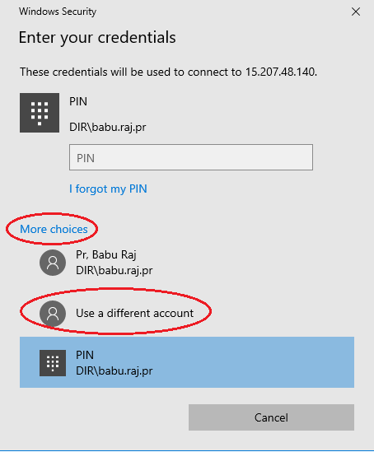

1. Enter the login credentials shared to you over the email.

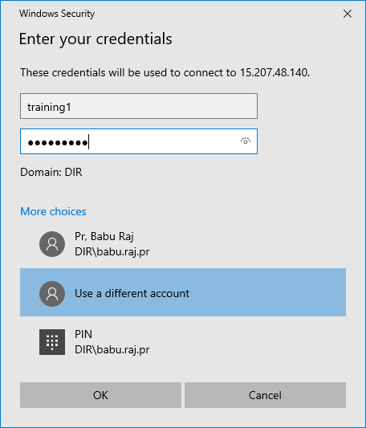

1. Click on **Yes**

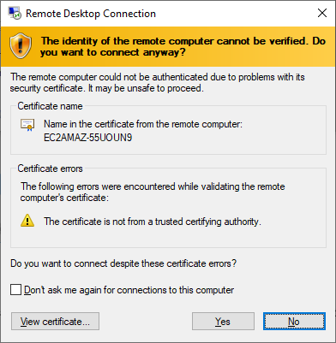

**Result**: You are now connected to the remote machine.



You can now start your training labs. Happy Learning!